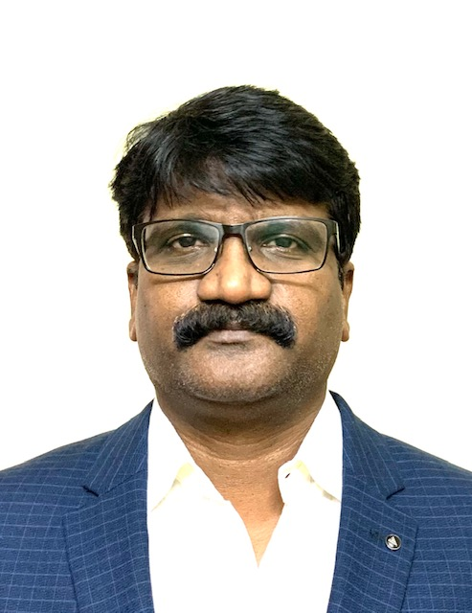  Mobile+91 9440437907  Email: l.vithal@gmail.com |  | Vithal RAO LANKAPLLI
PROFILE  Experienced IT Delivery Manager and Cloud Database Professional, offering over 20 years of experience in Cloud database solution architecture, Project management. Leadership skills in building Cloud Database Teams from scratch; evaluating training needs and streamlining processes to ensure smooth functioning. Perform key project management activities like planning, Resource and work allocation, Project tracking, status reporting, performance reporting, quality assurance.  EDUCATION  M.Tech Computer Aided manufacturing & Design JNTU Hyderabad.  B. Tech Industrial Production Engineering KL University Guntur.  SKILLS  - Service Delivery | Change management | Project Management | Leadership Team Management | Technology Road Map | Software Development | Infra Monitoring | Infra Requirement Gathering & Estimation  - Stakeholder management | Cloud services cost Estimation & optimization  - Process Improvement & IT Delivery Strategy | Vendor Management | Cloud security and compliance | Cloud Infra services cost optimization | AWS & Azure | Oracle cloud  - Project tracking |SDLC methodologies | Performance management | Customer Deliveries | Customer interaction | Customer Escalation and Support  - Fluency in dev ops | Python | Data pipeline Infrastructure management Implementation|  - | Designing | Planning | Solutioning | Architecture |  - Unix | C++ | Java | PL/SQL | Python |Jenkins | CLI  - Bigdata Hadoop | Hive | HBase | Sqoop | Scala | Pig | Kafka | SSIS, SSRS |  Certifications:  - ITIL Foundation Certificate in IT Service Management  - AWS Solutions Architect- Associate Level  - Oracle Database 12c Ocp |  | WORK EXPERIENCE  HighRadius Technologies - Hyderabad, India  - Cloud-Database Engineering Manager- AUG 2019 –Present  - Managed & ensured project deliveries in a timely manner involving seamless onsite/ offshore coordination and transparent communication with all stakeholders at all phases.  - Implemented Jenkins pipeline automation jobs for MySQL aurora grants backup, restore, creating proxy ports for servers, RDS stop/start, RDS resource scaleup/scale down, creating database clusters for new environment.  - Responsible for the change management, DR processes planning, conducting External DR exercise based on customers committed SLA, security compliance.  - Perform configuration of user accounts for QA, DEV, Production servers and creating roles for EC2, RDS, S3, CloudWatch, EBS resources to communicate with each other using IAM. Installed application on AWS EC2 instances and configured the storage on S3 buckets.  - Perform key project management activities like planning, work allocation, tracking, status reporting, performance reporting, quality assurance activities.  - SPOC for service delivery and responsible for 24 x 7 quality services Provide leadership and direction to Delivery teams Leading technical teams to mentor, motivate and help them to maintain high performance.  - Experience in multiple database technologies including database Architecture/Solutioning, Administration, System Analysis, Design, Development and Support for RDBMS and NOSQL (MongoDB)  - Terraform -> create aurora MySQL database clusters with binary log replication, DR setup, Tomcat and application server creations|  - AWS Lambda functions & python -> configure database & application aws virtual machines using Ansible playbooks.  - Ensure adherence to defined Database & Cloud development best practices and architecture strategy. Ensure that our applications and infrastructure are designed and implemented to the highest security standards thus maintaining and enhancing customer trust.  - Balance scope, schedule, budget, quality and risks, while monitoring contract and account commitments, reporting and responding to issues and risks associated with the delivery and service and Work with tech leads, architects, product owners, and other business groups to identify and prioritize technical and functional needs while managing ambiguity and change.  - Ensures the success of customer deployments, managing the planning and execution of contractual obligations, and coordinating the interaction of internal, partner and customer resources towards the completion of project delivery.  VTEKH Inc (Client Cox communications Georgia USA)  - Senior DBA/Architect Feb 2016–Aug 2019  - Performs senior-level responsibilities for the overall database architecture, design, installation, configuration, technical support, Planning 24x7 on-call support, hiring database experts, mentoring senior dba team.  - Create and maintain project plans and responsible for tracking of resources. Escalation management-Ownership, facilitation, action plan, and driving the escalation to closure.  - Consult in implementing policies, technical procedures and standards and documentation for preserving the integrity and security of data, through IAM policies, Security Group configuration, for all projects.  - Providing architectural guidance for the Cloud Hosting Services team planning the feasibility aspects of migrating data warehouse data to cloud.  - Extensive experience in planning, designing and implemented Disaster Recovery Solution with Oracle Exadata (X3-2, x4-2, x5-2, x7-2) and Oracle EM Cloud Control 12c/13c/19c  - Areas of expertise include In-Memory, Database Security, Multitenant, Partitioning, RAT, Cloud Management Pack for Oracle Database, High Availability (RAC), Database Replication (Oracle Golden Gate), Disaster Recovery Site, Space Management, Capacity Planning, Backup & Recovery.  - Configured Real-time Replication from Oracle to Hadoop and Oracle to MSSQL server using golden gate, data transfer using Scoop form multiple transactional database systems to Hadoop Cluster, Real time replication using Oracle12c Golden gate classical, integrated Replication bidirectional.  - MySQL Migration from on premise to AWS aurora MySQL, Replication, Backup and DR setup for AWS aurora MySQL clusters.  - Experience in Oracle cloud Integration’s service and Oracle SaaS.  DSTSYSTEMS – Hyderabad, India (Subsidiary of DSTSYSTEMS Inc. Kansas)  - Senior Manager Infrastructure & Database April 2006 - Feb 2016  - Managed Multiple Infrastructure teams (Unix, Networking and DBA) with max team size of 50, Hiring, capacity planning, mentoring and technical trainings, change approver,  - Reporting Directly to Senior Director Infrastructure, involved in multiple projects along with onsite Directors for better planning and execution of onsite & offshore support model to cover 24/7 for UNIX, dba & networking.  - Review the Project Work Plan with onsite counter parts and the Short-Term Onsite associate for Knowledge Transition and then present it to the onsite team to get it approved.  - Review the project plans created by reporting managers and leads for multiple service lines. Prepare a detailed Support & Delivery plan/work breakdown structure that includes functional and activity decomposition matrix for all new projects and key milestones for each phase of the SDLC.  - Objective and goal setting for reporting managers and their team, doing yearly performance appraisals, coaching and mentoring on new technologies.  - Periodic reviews with all the teams for offshore project status and Implemented Change control templates to meet organization goals for operation teams.  - Responsible for architecting, managing and supporting the organization’s enterprise 24x7 Database Infrastructure and providing high availability, fault-tolerance, scalability and security of the All-Database environments.  - Experience in Oracle Database Implementation, Planning, Designing, Installation, Upgrading and Maintaining Database Technologies (11g, 10g, 9i & 8i) MySQL, DB2 on traditional system  Telesource Management Consulting Pvt -- Ltd Hyderabad  - Senior Database Administrator - May 2005 - April 2006  - Installation, upgrades, patching, backup of Oracle 10g on RH Linux Advanced server 3.0/4.0 Replication scripts, conflict resolution scripts, data patches for the data canter, PL/SQL procedures and Triggers, packages & functions.  - Monitoring Replication, Load, space utilization, user connections, and online Automatic scheduled backups for all Remote databases. Written scripts for the recompiling the invalid objects for each upgrade of the production/qa servers.  - Prepared the automatic backup plans in the regular time intervals using Oracle Enterprise manager.  - Established the test environment for the advanced replication for two servers using Linux and oracle10g. Raising the Tar’s for the production related problems and solve the problems by explaining to the Oracle support team. Added separate non-system tablespace to indexes and dynamic tables and created the temporary tablespace groups.  Cambridge Technology Enterprises (CTE)- Hyderabad, India  - Senior DBA April 2004 - May 2005  - Sales Force Automation 2 (SFA2): Windows CE, SQLSERVER CE 2.0, Microsoft Access 2000, C#. Net, XML, Pocket PC Handelman Inc. USA is one of the largest supply-chain companies in the USA. The SFA2 application enables Handelman’s field employees to provide accurate, comprehensive and real-time views into the supply chain to track product location and availability  - Installation of Oracle 9i Enterprise Edition on RH Linux Advanced Server 3.0, WinNT/Win2K server and Apply patches. Database and application performance tuning using explain plan of long running queries.  - Storage, backup recovery, automated alerts for availability and Load monitoring. Responsible for application performance and Involved in Logical and physical database design/development for multiple databases.  Java Softech Pvt Ltd – Hyderabad, India  - Database Administrator-Developer Dec 2000- April 2004  - Clients: Parliament House Delhi India, BSNL, and Bank of Indonesia Installation of Oracle 9i Enterprise Edition on RH Linux /WinNT/Win2K server and patching. Database Storage Management, Security Administration, database User management Backup and Recovery, High availability, Database external connection management.  - MSSQL Server CE version data loading using C# program.

